1. Each item in a web shop belongs to a seller. To ensure service quality, each seller has a rating. The data are kept in the following two tables:

TABLE sellers

id INTEGER PRIMARY KEY,

name VARCHAR(30) NOT NULL,

rating INTEGER NOT NULL

TABLE items

id INTEGER PRIMARY KEY,

name VARCHAR(30) NOT NULL,

sellerId INTEGER REFERENCES sellers(id)

Write a query that selects the item name and the name of its seller for each item that belongs to a seller with a rating greater than 4.

1. App usage data are kept in the following table:

TABLE sessions

id INTEGER PRIMARY KEY,

userId INTEGER NOT NULL,

duration DECIMAL NOT NULL

Write a query that selects userId and average session duration for each user who has more than one session

1. You have two tables as defined below:

TABLE student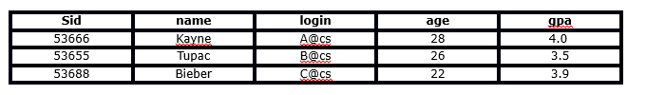

TABLE enrolled

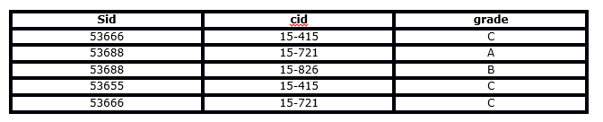

**Consider the queries:**

Query1: select name from enrolled LEFT OUTER JOIN student on student.sid = enrolled.sid;  
Query2: select name from student LEFT OUTER JOIN enrolled on student.sid = enrolled.sid;

**Which of the following option is correct and why?**

A. Queries 1 and 2 will give the same results

B. Queries 1 and 2 will give different results

C. Query 1 will produce an error and Query 2 will run successfully

D. Query 2 will produce an error and Query 1 will run successfully

Reason:

1. You have 4 tables as defined below

TABLE game

|  |  |  |  |  |
| --- | --- | --- | --- | --- |
| id | mdate | stadium | team1 | team2 |
| 1001 | 8 June 2012 | National Stadium, Warsaw | POL | GRE |
| 1002 | 8 June 2012 | Stadion Miejski (Wroclaw) | RUS | CZE |
| 1003 | 12 June 2012 | Stadion Miejski (Wroclaw) | GRE | CZE |
| 1004 | 12 June 2012 | National Stadium, Warsaw | POL | RUS |

TABLE goal

|  |  |  |  |
| --- | --- | --- | --- |
| matchid | teamid | player | gtime |
| 1001 | POL | Robert Lewandowski | 17 |
| 1001 | GRE | Dimitris Salpingidis | 51 |
| 1002 | RUS | Alan Dzagoev | 15 |
| 1001 | RUS | Roman Pavlyuchenko | 82 |

TABLE eteam

|  |  |  |
| --- | --- | --- |
| id | teamname | coach |
| POL | Poland | Franciszek Smuda |
| RUS | Russia | Dick Advocaat |
| CZE | Czech Republic | Michal Bilek |
| GRE | Greece | Fernando Santos |

* 1. Write the query to find the stadium where the player 'Dimitris Salpingidis' scored.

* 1. Write the query which shows the player, their team and the time they scored, for players who have played in Stadion Miejski (Wroclaw) but not against Italy(ITA)
  2. What result would be obtained from this code:

**SELECT** teamname, **COUNT**(*)

**FROM** eteam **JOIN** goal **ON** teamid = id

**GROUP** **BY** teamname

**HAVING** **COUNT**(*) < 3